
INTERNSHIP REPORT
Data Analytics Internship
Exploratory Data Analysis of Movies Dataset
This internship report is submitted in partial fulfilment for the completion of the internship program
Submitted By
Name: Rakshanda Gurung
Intern ID: NN/IN/1152
Designation: Data Analyst Intern
Submitted to
Company Name: Nova Nectar Services PVT. LTD.
Mentor: Surya Deep Das
Internship Duration
From: 26/11/2025
To: 28/02/2026

INDEX

S.No | Title | Page
1 | Acknowledgement | 3
2 | Introduction | 4
3 | Objectives of the project | 5
4 | Tools and technologies used | 5
5 | Dataset Description | 5
6 | Methodology | 6
7 | Key Features of the application | 6
8 | Results and insights | 7
9 | Conclusion | 7
10 | Future Scope | 7
11 | Project Snapshots | 8-10
12 | Bibliography | 11

ACKNOWLEDGEMENT
I would like to express my sincere gratitude to all those who contributed to the successful completion of this project titled “Exploratory Data Analysis of Movies Dataset Using Streamlit”.
First and foremost, I am thankful to my mentor for their valuable guidance, encouragement, and continuous support throughout the development of this project. Their insights helped me understand both the theoretical and practical aspects of data analysis.
I would also like to thank the open-source community for providing powerful libraries such as Pandas, Matplotlib, Seaborn, and Streamlit, which made this project possible. Special appreciation goes to the developers of Streamlit for enabling rapid development of interactive data applications.

INTRODUCTION
In the modern era of data-driven decision-making, Exploratory Data Analysis (EDA) plays a crucial role in understanding the structure, patterns, and insights hidden within raw datasets. The entertainment industry, especially the film industry, generates a large volume of data related to movies, ratings, budgets, and audience preferences.
This project focuses on performing Exploratory Data Analysis on a Movies Dataset using Streamlit, an interactive web application framework for Python. The goal is to transform raw movie data into meaningful insights through data cleaning, statistical analysis, and visualizations.
The application automatically loads a CSV dataset, monitors file updates in real time, and presents comprehensive visual analytics such as summary statistics, missing value analysis, and numerical distributions. By integrating auto-refresh functionality, the project ensures that any changes in the dataset are reflected instantly on the dashboard.
This project demonstrates how Python-based data analysis combined with interactive visualization tools can be effectively used to analyze real-world datasets in an intuitive and user-friendly manner.

OBJECTIVES OF THE PROJECT
The main objectives of this project are:
- To load and analyze a Movies dataset using Python
- To perform Exploratory Data Analysis (EDA)
- To identify missing values and duplicate records
- To generate statistical summaries of the dataset
- To visualize numerical distributions using graphs
- To build an interactive data dashboard using Streamlit
- To implement auto-refresh functionality for real-time updates

TOOLS AND TECHNOLOGIES USED
Tool / Library | Purpose
Python | Programming Language
Streamlit | Web Application Framework
Pandas | Data Manipulation & Analysis
Matplotlib | Data Visualization
Seaborn | Statistical Data Visualization
OS & Time | File tracking and refresh logic
DATASET DESCRIPTION
- Dataset Name: Movies Dataset
- File Format: CSV
- Data Source: Local system
- Content: Movie-related attributes such as ratings, release year, revenue, etc.

METHODOLOGY
- Data Loading
  - The dataset is loaded using Pandas.
  - File modification time is tracked to detect updates.
- Data Cleaning
  - Missing values and duplicate records are identified.
  - Rows with null values and duplicates are removed.
- Exploratory Data Analysis
  - Dataset shape and data types are displayed.
  - Summary statistics are generated.
  - Missing value heatmaps are plotted.
  - Numerical features are analyzed using histograms.
- Visualization
  - Seaborn and Matplotlib are used for plotting.
  - Streamlit renders interactive graphs.
- Automation
  - Auto-refresh updates the dashboard every 5 seconds.
  - Cached data improves performance.

KEY FEATURES OF THE APPLICATION
- Interactive Streamlit dashboard
- Automatic dataset refresh
- Full dataset preview
- Summary statistics & missing value analysis
- Heatmap visualization
- Histogram plots for numerical columns
- Automated insights generation

RESULTS AND INSIGHTS
- The dataset structure and size were successfully analyzed.
- Missing values were detected and visualized effectively.
- Numerical distributions revealed data skewness and trends.
- Duplicate and null entries were removed for cleaner analysis.
- The dashboard provided real-time updates with minimal latency.

CONCLUSION
This project successfully demonstrates the use of Streamlit for Exploratory Data Analysis on a Movies dataset. The interactive dashboard simplifies data understanding and enhances user engagement through visual analytics.
By integrating data cleaning, visualization, and automation features, the application serves as an effective tool for analyzing movie-related data. This project highlights the importance of EDA in data science workflows and showcases how Python libraries can be leveraged to build professional-grade analytical applications.

FUTURE SCOPE
- Integration of filters and dropdowns for user interaction
- Addition of genre-wise and year-wise analysis
- Deployment on cloud platforms (Streamlit Cloud)
- Machine learning-based movie rating prediction

PROJECT SNAPSHOTS

Figure 1: Streamlit Dashboard – Movies Dataset Loaded Successfully
This snapshot shows the Streamlit application interface with successful dataset loading, last updated time, original dataset shape, and preview of the full movies dataset.

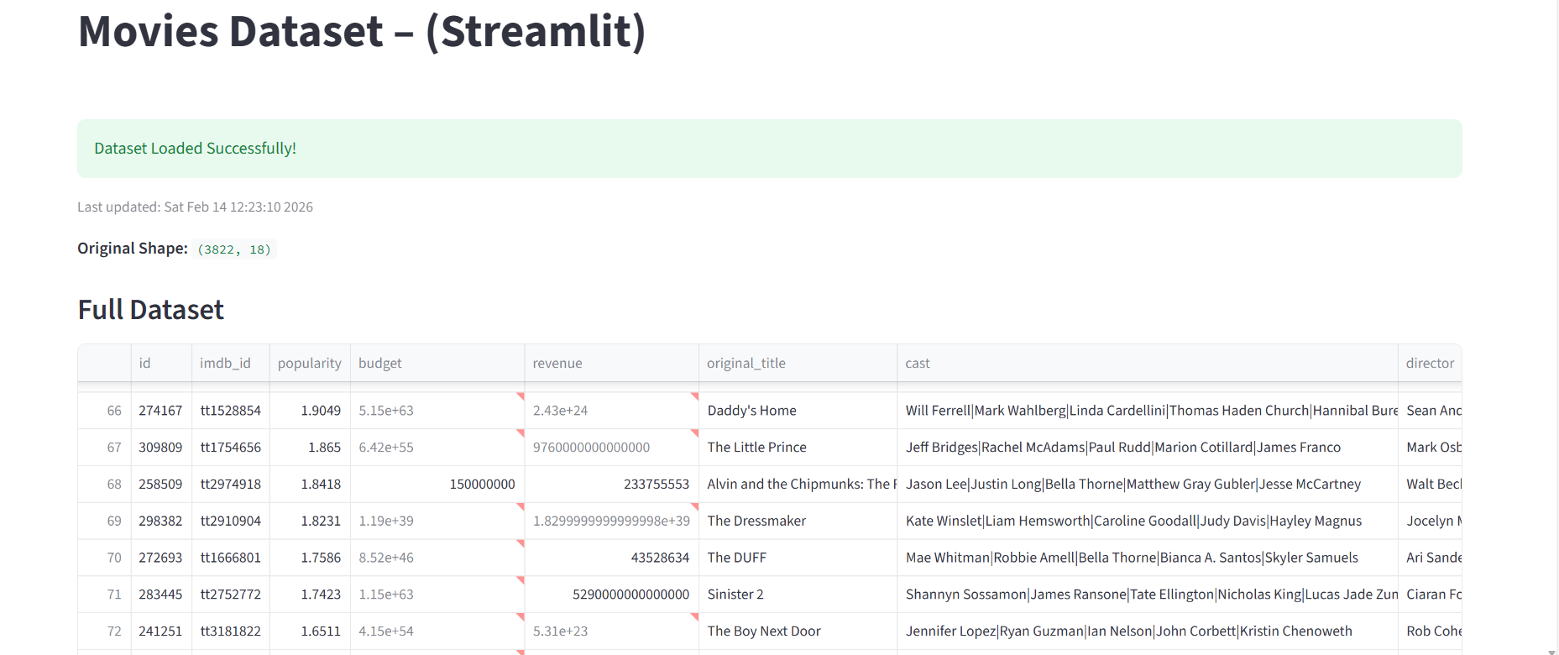
Figure 2: Dataset Information – Column Names and Data Types
This snapshot displays the structural information of the dataset, including column names and their corresponding data types, helping to understand the schema of the Movies dataset.

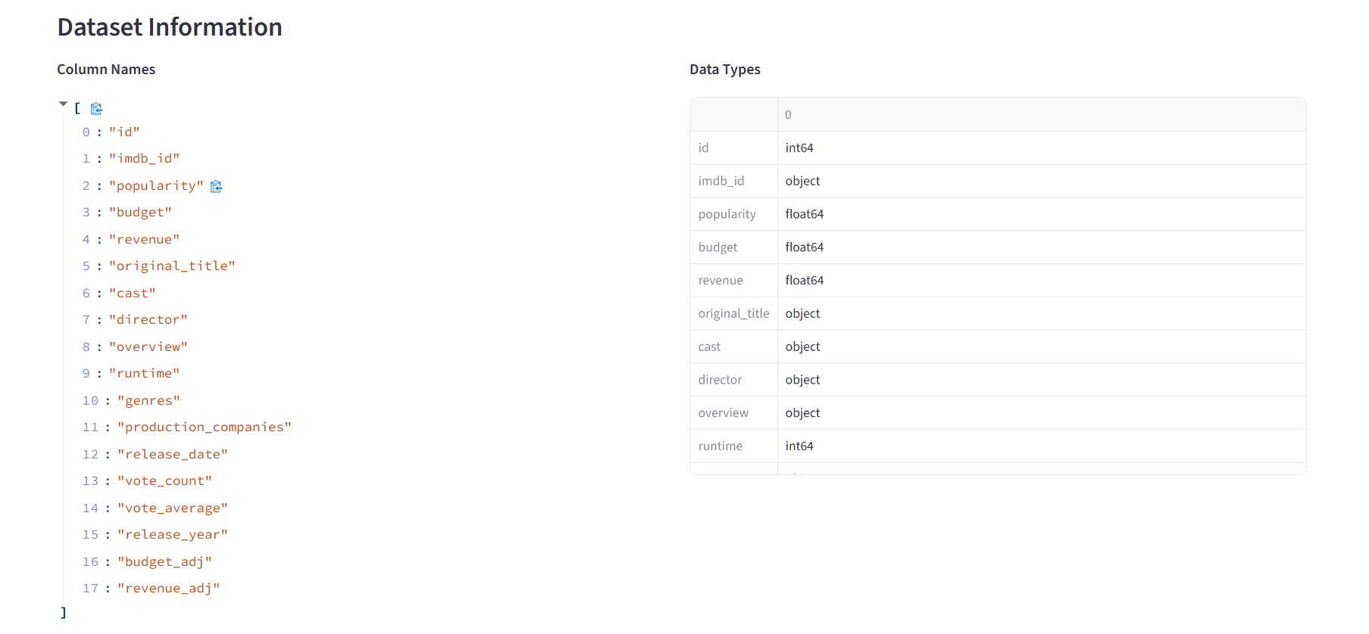

Figure 3: Summary Statistics of Movies Dataset
This snapshot presents descriptive statistics such as count, mean, standard deviation, minimum, maximum, and quartiles for both numerical and categorical features.

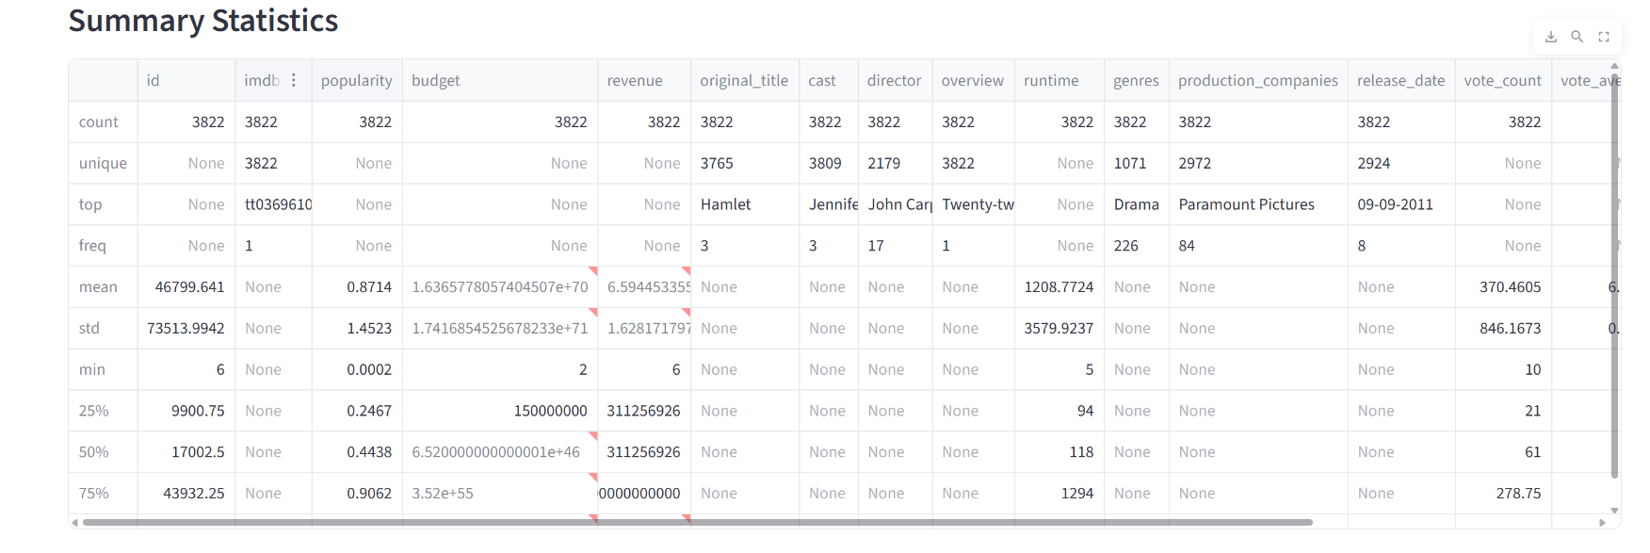
Figure 4: Histogram Distribution of Movie ID
This snapshot represents the frequency distribution of movie identifiers, showing a right-skewed pattern with a high concentration of values at lower ranges.

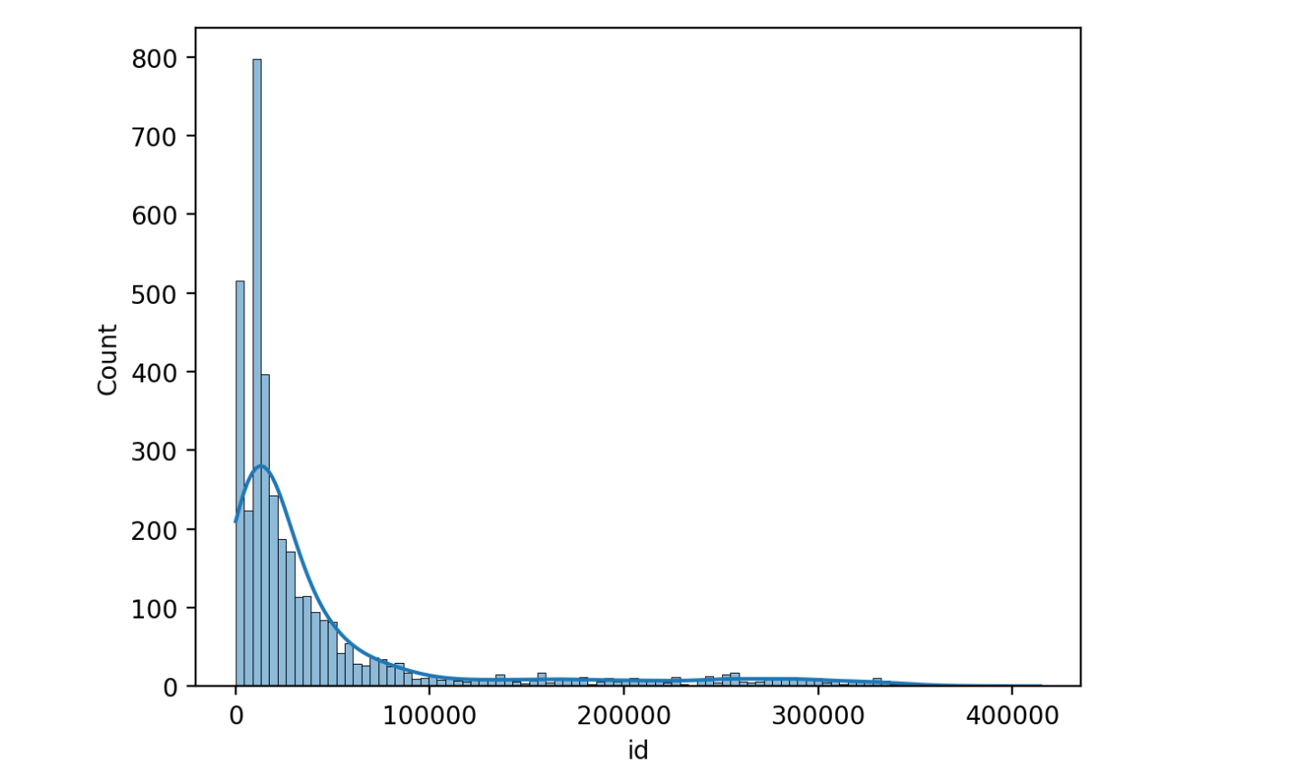

Figure 5: Histogram Distribution of Movie Popularity
This snapshot illustrates the distribution of movie popularity scores, highlighting a strong right-skewness where most movies have low popularity values while a few have very high popularity.

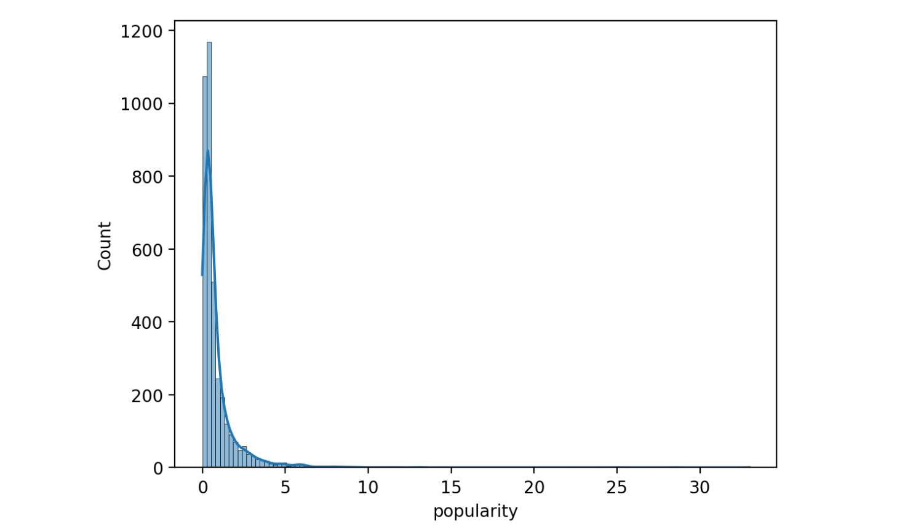

Figure 6: Histogram Distribution of Movie Release Year
This snapshot illustrates the distribution of movies released across different years, highlighting trends in movie production and an increase in releases in recent decades.

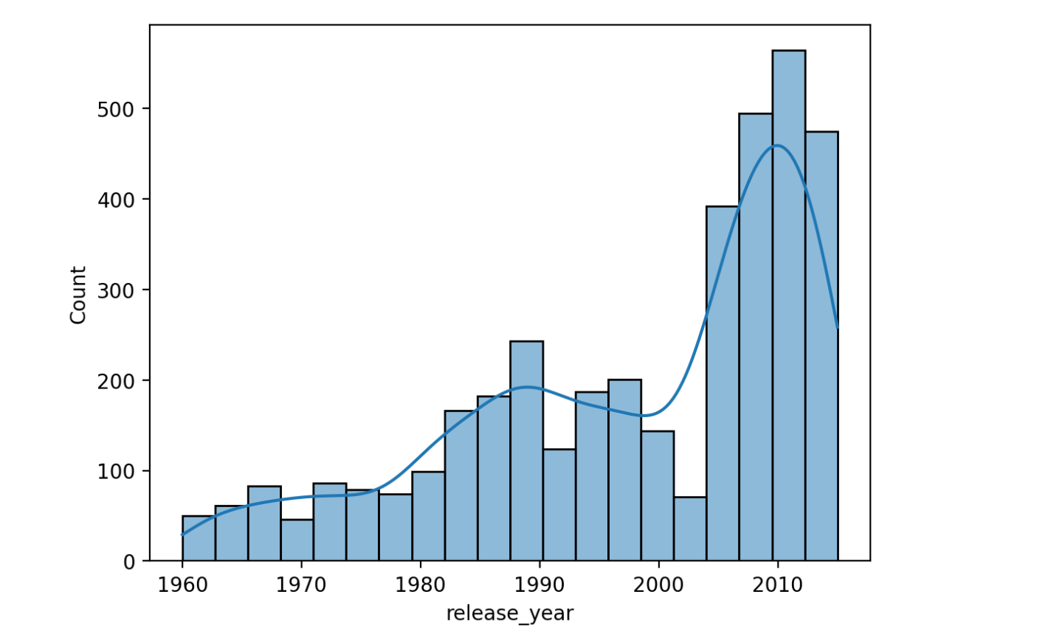

BIBLIOGRAPHY
- Streamlit Documentation.
Streamlit: The fastest way to build data apps in Python.
Available at: https://docs.streamlit.io
- McKinney, W. (2010).
Data Structures for Statistical Computing in Python.
Proceedings of the 9th Python in Science Conference.
- Pandas Documentation.
Pandas – Python Data Analysis Library.
Available at: https://pandas.pydata.org/docs
- Hunter, J. D. (2007).
Matplotlib: A 2D Graphics Environment.
Computing in Science & Engineering, IEEE.
- Seaborn Documentation.
Statistical Data Visualization in Python.
Available at: https://seaborn.pydata.org
- Python Software Foundation.
Python Programming Language Documentation.
Available at: https://docs.python.org/3
- Kaggle.
Movies Dataset for Exploratory Data Analysis.
Available at: https://www.kaggle.com

